

|  |  |  |
| --- | --- | --- |
| **Introduction to AI &ML** | | |
| Lab Manual | | |
| **Department of Computer Science and Engineering**  **The NorthCap University, Gurugram** | | |
|  | |
|  | |
|  | |
|  | |
|  |

**Introduction to AI &ML Lab Manual**

**CSL 236**



Department of Computer Science and Engineering

NorthCap University, Gurugram- 122001, India

Session 2021-22

*Published by:*

**School of Engineering and Technology**

**Department of Computer Science & Engineering**

**The NorthCap University Gurugram**

**• Laboratory Manual is for Internal Circulation only**

**© Copyright Reserved**

*No part of this Practical Record Book may be*

*reproduced, used, stored without prior permission of The NorthCap University*



Copying or facilitating copying of lab work comes under cheating and is considered as use of unfair means. Students indulging in copying or facilitating copying shall be awarded zero marks for that particular experiment. Frequent cases of copying may lead to disciplinary action. Attendance in lab classes is mandatory.

Labs are open up to 7 PM upon request. Students are encouraged to make full use of labs beyond normal lab hours.

**PREFACE**

Machine LearningLab Manual is designed to meet the course and program requirements of NCU curriculum for B.Tech III year students of CSE branch. The concept of the lab work is to give brief practical experience for basic lab skills to students. It provides the space and scope for self-study so that students can come up with new and creative ideas.

The Lab manual is written on the basis of “teach yourself pattern” and expected that students who come with proper preparation should be able to perform the experiments without any difficulty. Brief introduction to each experiment with information about self-study material is provided. The pre-requisite is having a basic working knowledge of Python. The laboratory exercises will include familiarization with data pre-processing techniques for ML like handling missing data, duplicate data, outliers feature scaling and encoding. Feature Selection and Dimensionality Reduction are included to enhance the performance and reduce the computational time. Various ML classification and regression techniques are taught. Students would learn the algorithms pertaining to these and implement the same using a high-level language, i.e. Python. Students are expected to come thoroughly prepared for the lab.General disciplines, safety guidelines and report writing are also discussed.

The lab manual is a part of curriculum for the TheNorthCap University, Gurugram. Teacher’s copy of the experimental results and answer for the questions are available as sample guidelines.

We hope that lab manual would be useful to students of CSE, IT, ECE and BSc branches and author requests the readers to kindly forward their suggestions / constructive criticism for further improvement of the work book.

Author expresses deep gratitude to Members, Governing Body-NCU for encouragement and motivation.

**Authors**

**The NorthCap University**

**Gurugram, India**

|  |  |  |  |
| --- | --- | --- | --- |
| **CONTENTS** | | | |
| S.N. | **Details** | Page No. | |
|  | **Syllabus** | 6 | |
| 1 | **Introduction** | 9 | |
| 2 | **Lab Requirement** | 10 |
| 3 | **General Instructions** | 11 |
| 4 | **List of Experiments** | 13 |
| 5 | **List of Flip Assignment** | 14 |
| 6 | **List of Projects** | 15 |
| 7 | **Rubrics** | 16 |
| 8 | **Annexure 1 (Format of Lab Report)** | 18 |

**SYLLABUS**

|  |  |  |  |  |  |  |  |  |  |
| --- | --- | --- | --- | --- | --- | --- | --- | --- | --- |
| 1. **Department:** | | | Department of Computer Science and Engineering | | | | | | |
| 1. **Course Name: Machine Learning** | | | | | 1. **Course Code** | 1. **L-T-P** | | | 1. **Credits** |
| CSL236 | 3-0-2 | | | 4 |
| 1. **Type of Course (Check one):** | | | **✓**  Programme Core Programme Elective **✓**Open Elective | | | | | | |
| 1. **Pre-requisite(s), if any:** Introduction to AI and ML | | | | | | | | | |
| 1. **Frequency of offering (check one):** Odd Even **✓** Either semester Every semester | | | | | | | | | |
| 1. **Brief Syllabus:**   Introduction to artificial intelligence, History of AI, Proposing and evaluating AI application, Preprocessing and Feature Engineering, Case study: Exploratory Analysis of Delhi Pollution, Simple Linear Regression, Multiple Regression, Polynomial Regression, Support Vector Regression SVR, Decision Tree Regression, Random Forest Regression, Logistic Regression, K Nearest Neighbors, Support Vector Machine, Kernel SVM, Naïve Bayes, Decision Trees Classification, Random Forest Classification, Basic Terminologies: Overfitting, Underfitting, Bias and Variance model, Bootstrapping, Cross-Validation and Resampling Methods, Performance Measures: Confusion matrix, ROC. Comparing two classification Algorithms:  McNamara’s Test, paired t-test. | | | | | | | | | |
| **Total lecture, Tutorial and Practical Hours for this course (Take 15 teaching weeks per semester): 75** hours  The class size is maximum 30 learners | | | | | | | | | |
| **Lectures: 40** hours | | | | **Practice** | | | | | |
| **Tutorials:** 0 hours | | | **Lab Work: 35**hours | | |
| 1. **Course Outcomes (COs)**   On successful completion of this course students will be able to: | | | | | | | | | |
| **CO 1** | Understand and implement the preprocessing of the data to be used for machine learning models. | | | | | | | | |
| **CO 2** | Understand the strengths and limitations of various ML algorithms. | | | | | | | | |
| **CO 3** | Understand why models degrade and how to maintain them. | | | | | | | | |
| **CO 4** | Implement and use model grading metrics. | | | | | | | | |
| **CO 5** | Apply ML techniques and technologies to solve real world business problems. | | | | | | | | |
| 1. **UNIT WISE DETAILS No. of Units: 5** | | | | | | | | | |
| **Unit Number: 1** | | **Title: Introduction to AI and ML** | | | | | | **No. of hours: 4** | |
| **Content Summary:**  Introduction to artificial intelligence, History of AI, Overview of machine learning, techniques in machine learning, deep learning, differences between deep learning, machine learning and AI, different applications of machine learning, different types of data. | | | | | | | | | |
| **Unit Number: 2** | | **Data preprocessing and engineering** | | | | | | **No. of hours:10** | |
| Content Summary:  Introduction to Data Preprocessing, different preprocessing techniques, data cleaning, data transformation: standardization and normalization, data smoothing, dimensionality reduction, different encoding schemes for categorical and numerical features. | | | | | | | | | |
| **Unit Number: 3** | | **Title: Regression Techniques** | | | | | | **No. of hours:12** | |
| **Content Summary:**  Simple Linear Regression, Multiple Regression, Polynomial Regression, Support Vector Regression SVR, Decision Tree Regression, Random Forest Regression | | | | | | | | | |
| **Unit Number: 4** | | **Title: Classification algorithm techniques** | | | | | | **No. of hours:12** | |
| Logistic Regression, K Nearest Neighbors, Support Vector Machine, Kernel SVM, Naïve Bayes, Decision Trees Classification, Random Forest Classification | | | | | | | | | |
| **Unit Number: 5** | | **Title: Analysis of various algorithms** | | | | | | **No. of hours:7** | |
| Basic Terminologies: Over fitting, Under fitting, Bias and Variance model, Bootstrapping, Cross-Validation and Resampling Methods, Performance Measures: Confusion matrix, ROC. | | | | | | | | | |
| 1. **Brief Description of Self-learning components by students (through books/resource material etc.):**   Data-preprocessing techniques | | | | | | | | | |
| **13. Advance Learning Components:**  Probability and Statistics and Linear Algebra | | | | | | | | | |
| **14. Books Recommended :**  **Text Books:**  1. Michael Bowles, “Machine Learning in Python ” Wiley, Third Edition, 2019 2. Jiawei Han, Micheline Kamber and Jian Pei. Data Mining: Concepts and Techniques, 3rd ed.  **Reference Books:**  1. Ian H.Witten &Eibe Frank., “Data Mining Practical Machine Learning Tools and Techniques”, Morgan Kauffmann Publishers, Second Edition, 2010  2. EthemAlpaydin, “Introduction to Machine Learning”, MIT Press, Third Edition, 2015  3. Tom Mitchell. Machine Learning. Mc Graw Hill  **Reference Websites: (NPTEL, Swayam, Coursera, Edx, Udemy, LMS, official documentation weblink)**   * [**https://nculms.ncuindia.edu/**](https://nculms.ncuindia.edu/) * [**https://www.simplilearn.com/big-data-and-analytics/machine-learning-certification-training-course**](https://www.simplilearn.com/big-data-and-analytics/machine-learning-certification-training-course) * [**https://www.coursera.org/learn/machine-learning**](https://www.coursera.org/learn/machine-learning) | | | | | | | | | |

1. **INTRODUCTION**

That ‘learning is a continuous process’ cannot be over emphasized. The theoretical knowledge gained during lecture sessions need to be strengthened through practical experimentation. Thus, practical makes an integral part of a learning process.

**OBJECTIVE:**

The purpose of conducting experiments can be stated as follows:

* To familiarize the students with the basic concepts of Machine Learning like supervised, unsupervised and reinforcement learning.
* The lab sessions will be based on exploring the concepts discussed in class.
* Learning and understanding Data Preprocessing techniques.
* Learning and understanding regression and classification problems and algorithms.
* Learning and understanding Feature selection and Dimensionality Reduction.
* Learning and understanding performance metrics.
* Hands on experience

1. **LAB REQUIREMENTS**

|  |  |  |
| --- | --- | --- |
| **S.No.** | **Requirements** | **Details** |
| **1** | **Software Requirements** | Python 3. |
| **2** | **Operating System** | Windows(64-bit), Linux |
| **3** | **Hardware Requirements** | 8 GB RAM (Recommended)  2.60 GHz (Recommended) |
| **4** | **Required Bandwidth** | NA |

1. **GENERAL INSTRUCTIONS** 
   1. **General discipline in the lab**
   * Students must turn up in time and contact concerned faculty for the experiment they are supposed to perform.
   * Students will not be allowed to enter late in the lab.
   * Students will not leave the class till the period is over.
   * Students should come prepared for their experiment.
   * Experimental results should be entered in the lab report format and certified/signed by concerned faculty/ lab Instructor.
   * Students must get the connection of the hardware setup verified before switching on the power supply.
   * Students should maintain silence while performing the experiments. If any necessity arises for discussion amongst them, they should discuss with a very low pitch without disturbing the adjacent groups.
   * Violating the above code of conduct may attract disciplinary action.
   * Damaging lab equipment or removing any component from the lab may invite penalties and strict disciplinary action.
   1. **Attendance**

* Attendance in the lab class is compulsory.
* Students should not attend a different lab group/section other than the one assigned at the beginning of the session.
* On account of illness or some family problems, if a student misses his/her lab classes, he/she may be assigned a different group to make up the losses in consultation with the concerned faculty / lab instructor. Or he/she may work in the lab during spare/extra hours to complete the experiment. No attendance will be granted for such case**.**
  1. **Preparation and Performance**
* Students should come to the lab thoroughly prepared on the experiments they are assigned to perform on that day. Brief introduction to each experiment with information about selfstudy reference is provided on LMS.
* Students must bring the lab report during each practical class with written records of thelast experiments performed complete in all respect.
* Each student is required to write a complete report of the experiment he has performed and bring to lab class for evaluation in the next working lab. Sufficient space in work book is provided for independent writing of theory, observation, calculation and conclusion.
* Students should follow the Zero tolerance policy for copying / plagiarism. Zero marks will be awarded if found copied. If caught further, it will lead to disciplinary action.
* Refer **Annexure 1** for Lab Report Format

1. **LIST OF EXPERIMENTS**

|  |  |  |  |  |  |
| --- | --- | --- | --- | --- | --- |
| **Sr. No.** | **Title of the Experiment** | **Software**  **used** | **Unit**  **Covered** | **CO**  **Covered** | **Time**  **Required** |
| **1** | To introduce various python libraries used for machine learning. | Python  (Jupyter) | 1 | CO1 | 4 hours |
| 2 | To apply various data pre-processing techniques used for effective machine learning on the given dataset. | Python  (Jupyter) | 1 | CO1 | 2 hours |
| 3 | To apply feature encoding schemes such as label encoder and onehotencoder. | Python  (Jupyter) | 1 | CO1 | 3 hours |
| 4 | To apply different feature selection techniques in machine learning. | Python  (Jupyter) | 1 | CO1 | 3 hours |
| 5 | To apply PCA as feature reduction technique on IRIS dataset. | Python  (Jupyter) | 2 | CO1 | 2 hours |
| 6 | To apply Simple Linear Regression on the given dataset. | Python  (Jupyter) | 2 | CO2, CO3, CO4 | 2 hours |
| 7 | To apply multiple linear regression on any regression dataset. | Python  (Jupyter) | 2 | CO2,CO3,CO4 | 3 hours |
| 8 | To apply Polynomial Linear Regression on the given dataset. | Python  (Jupyter) | 2 | CO2,CO3,CO4 | 3 hours |
| 9 | To solve classification problems using Logistic Regression. | Python  (Jupyter) | 3 | CO2,CO3,CO4 | 2 hours |
| 10 | To solve classification problems using KNN classification. | Python  (Jupyter) | 3 | CO2,CO3,CO4 | 2 hours |
| 11 | To solve classification problems using Naïve Bayes. | Python  (Jupyter) | 4 | CO2,CO3,CO4 | 2 hours |
| 12 | To apply Support Vector Machines (SVM) on classification problems. | Python  (Jupyter) | 4 | CO2,CO3,CO4 | 3 hours |
| 13 | To apply Decision Trees for classification problems. | Python  (Jupyter) | 4 | CO2,CO3,CO4 | 3 hours |
| **Value Added Experiments** | | | | | |
| 14 | Build a ML model from scratch using data-preprocessing and regression algorithms and calculating various performance metrics. | Python  (Jupyter) | 1,2,3,4 | CO1,CO2,  CO3,CO4,CO5 | 5 hours |
| 15 | Build a ML model from scratch using data-preprocessing and classification algorithms and calculating various performance metrics. | Python  (Jupyter) | 1,2,3,4 | CO1,CO2,  CO3,CO4,CO5 | 5 hours |

1. **LIST OF FLIP EXPERIMENTS**
2. Project – Dimensionality reduction using LDA.
3. Competition on Kaggle
4. **LIST OF PROJECTS**
   * + 1. Titanic Challenge: The sinking of the Titanic is one of the most infamous shipwrecks in history.On April 15, 1912, during her maiden voyage, the widely considered “unsinkable” RMS Titanic sank after colliding with an iceberg. Unfortunately, there weren’t enough lifeboats for everyone onboard, resulting in the death of 1502 out of 2224 passengers and crew.While there was some element of luck involved in surviving, it seems some groups of people were more likely to survive than others.In this project, the students need to build a predictive model that answers the question: “what sorts of people were more likely to survive?” using passenger data (ie name, age, gender, socio-economic class, etc)*.*
       2. House Price Prediction Using Advanced Regression Techniques: Ask a home buyer to describe their dream house, and they probably won't begin with the height of the basement ceiling or the proximity to an east-west railroad. But Kaggle’s advanced house price prediction dataset proves that much more influences price negotiations than the number of bedrooms or a white-picket fence. With 79 explanatory variables describing (almost) every aspect of residential homes in Ames, Iowa, this dataset can be used to predict the final price of each home.
       3. Mechanism of Action (MoA) Prediction: Mechanism of action means the biochemical interactions through which a drug generates its pharmacological effect. If we know a disease affects some particular receptor or downstream set of cell activity, we can develop drugs faster if we can predict how cells and genes affect various receptor sites.  Using a dataset that combines gene expression and cell viability data in addition to the MoA annotations of more than 5,000 drugs. In this, each drug was tested under two dose (cp_dose) and three times (cp_time). So, six samples basically correspond to one drug. We need to train a model that classifies drugs based on their biological activity. This problem is a multi-label classification, which means we have multiple targets (not multiple classes). In this project, perform explanatory data analysis and then train a model using deep neural networks with Keras.
5. **RUBRICS**

|  |  |
| --- | --- |
| **Marks Distribution** | |
| **Continuous Evaluation(20 Marks)** | **Project Evaluations (30 Marks)** |
| Each experiment shall be evaluated for 10 marks and at the end of the semester proportional marks shall be awarded out of total 20. | Both the projects shall be evaluated for 30 marks each and at the end of the semester viva will be conducted related to the projects as well as concepts learned in labs and this component carries 20 marks. |
| Following is the breakup of 10 marks for each  **4 Marks**: Observation & conduct of experiment. Teacher may ask questions about experiment.  **3 Marks:** For report writing  **3 Marks:** For the 15 minutes quiz to be conducted in every lab. |

**Annexure 1**

**Introduction to AI and ML**

**(CSL 236)**

**Lab Practical Report**



Faculty name: Nidhi Malik

Student name: Avtar Singh

Roll No.: 20csu241

Semester: 5th

Group: Fsb

**Department of Computer Science and Engineering**

**NorthCap University, Gurugram- 122001, India**

**Session 2021-22**

**INDEX**

|  |  |  |  |  |  |  |  |
| --- | --- | --- | --- | --- | --- | --- | --- |
| **S.No** | **Experiment** | **Page No.** | **Date of Experiment** | **Date of Submission** | **Marks** | **CO Covered** | **Sign** |
| **1** | To introduce various python libraries used for machine learning. |  |  |  |  |  |  |
| **2** | To apply various data pre-processing techniques used for effective machine learning on the given dataset. |  |  |  |  |  |  |
| **3** | To apply feature encoding schemes such as label encoder and onehotencoder. |  |  |  |  |  |  |
|  |  |  |  |  |  |  |  |
|  |  |  |  |  |  |  |  |
|  |  |  |  |  |  |  |  |
|  |  |  |  |  |  |  |  |
|  |  |  |  |  |  |  |  |
|  |  |  |  |  |  |  |  |

**EXPERIMENT NO. 1**

|  |
| --- |
| **Student Name and Roll Number: Avtar Singh / 20CSU241 Avtar 20csu241** |
| **Semester /Section: 5th / FSB5th / FS-B** |
| **Date: 18/08/2022** |
| **Faculty Signature:** |
| **Grade:** |

|  |
| --- |
| **Objective(s):**   * To understand the basic libraries of python. * To differentiate between numpys and pandas. |
| **Outcome:**  Students will be familiarized with handling dataset using python basic libraries and applying various operations on dataset using these. |
| **Problem Statement:**  To introduce various libraries of python used for machine learning. |
| **Background Study:**  **Basic libraries** ofpython are necessary to import datasets and applying various data pre-processing and machine learning techniques on them. |
| **Question Bank:**  1. How pandas can be used to read data from internet and from your system?  ANS. **the Pandas read_csv() function returns a new DataFrame with the data and labels from the file data.** **csv** , which you specified with the first argument.  2.How pandas dataframe can be converted to numpy arrays and vice versa?  ANS. We can do this by using **dataframe.** **to_numpy() method**. This will convert the given Pandas Dataframe to Numpy Array.  4. Differentiate between Feature Selection and Dimensionality Reduction.  Ans. While both methods are used for reducing the number of features in a dataset, there is an important difference. **Feature selection is simply selecting and excluding given features without changing them.** Dimensionality reduction transforms features into a lower dimension.  5. What are the advantages of Wrapper methods over filter methods for feature selection?  Ans.Filter methods might fail to find the best subset of features in many occasions but wrapper methods can always provide the best subset of features. Using the subset of features from the wrapper methods **make the model more prone to overfitting** as compared to using subset of features from the filter methods.  6.Explain Regularization methods for Feature Selection.  Ans.Regularisation consists in **adding a penalty to the different parameters of the machine learning model to reduce the freedom of the model and in other words to avoid overfitting**. In linear model regularisation, the penalty is applied over the coefficients that multiply each of the predictors.  7. What are Embedded feature selection methods.  Ans.Embedded methods **combine the qualities' of filter and wrapper methods**. It's implemented by algorithms that have their own built-in feature selection methods. Some of the most popular examples of these methods are LASSO and RIDGE regression which have inbuilt penalization functions to reduce overfitting. |

**Student Work Area**

**Algorithm/Flowchart/Code/Sample Outputs**

**1.**

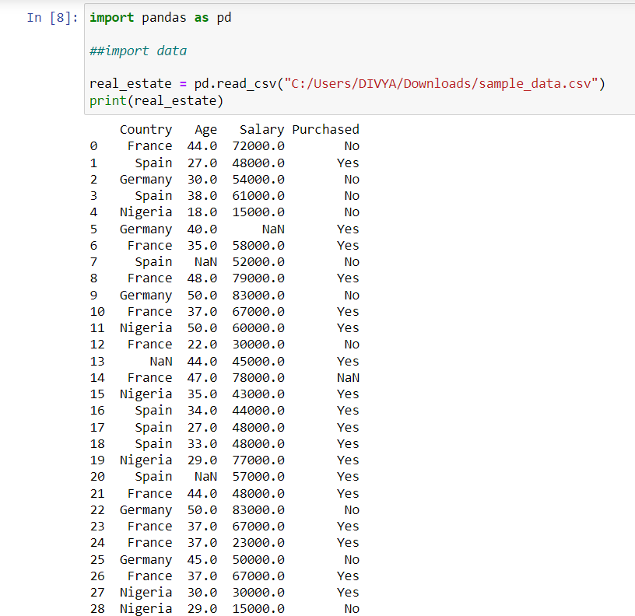

**2.**

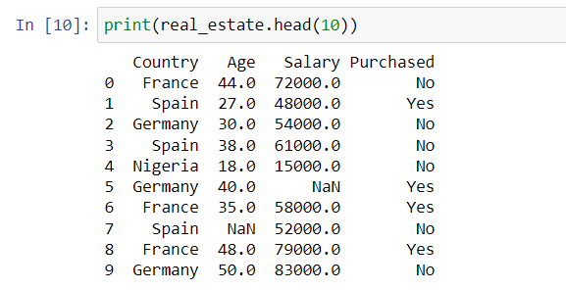

**3.**

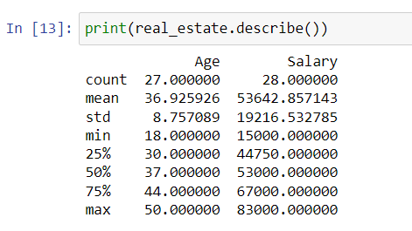

**4.**

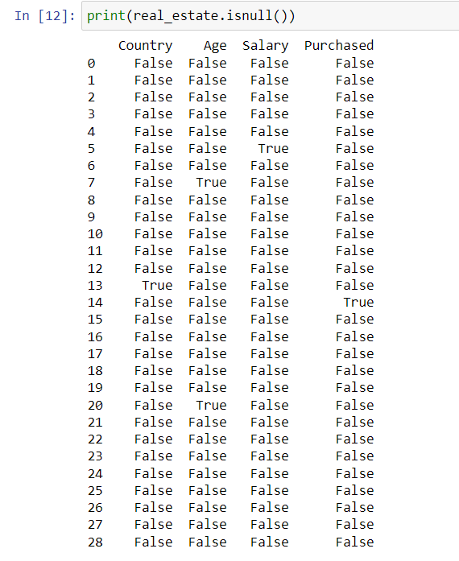

**5.**

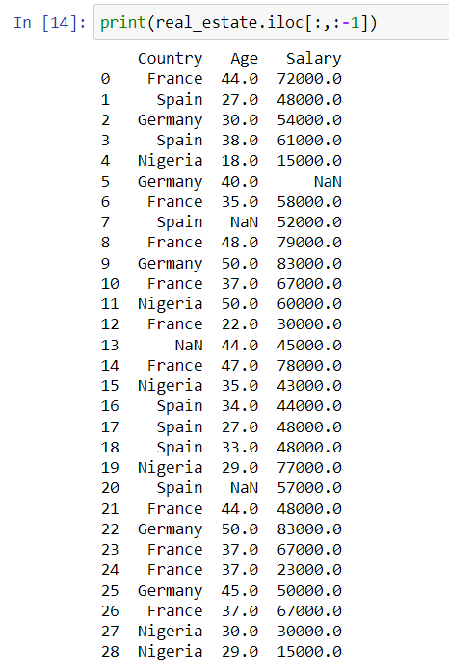

**6.**

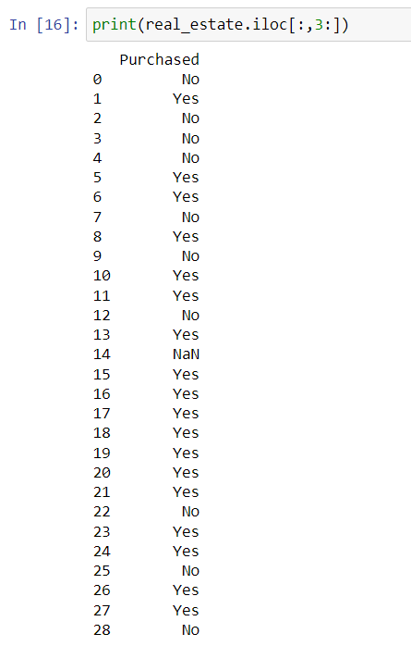

**7.**

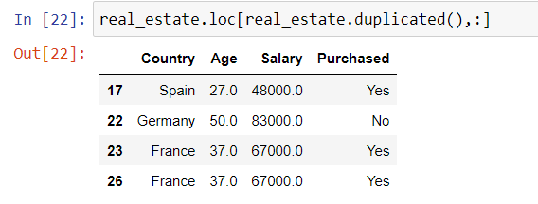

|  |
| --- |
|  |
|  |
|  |
|  |
|  |
|  |

**EXPERIMENT NO. 2**

|  |
| --- |
| **Student Name and Roll Number: Avtar Singh / 20CSU241 Avtar Singh 20csu241** |
| **Semester /Section: 5th / FSB 5th/FSB** |
| **Link to Code:** |
| **Date: 01/09/2022** |
| **Faculty Signature:** |
| **Grade:** |

|  |
| --- |
| **Objective(s):**   * To understand the importance of data pre-processing techniques. * To handle missing values, duplicate values, feature scaling etc. |
| **Outcome:**  Students will be familiarized with the understanding and importance of applying various data pre-processing techniques. |
| **Problem Statement:**  Write a program to perform data pre-processing techniques for effective machine learning. |
| **Background Study:**Data preprocessing in Machine Learning is a crucial step thathelps enhance the quality of data to promote the extraction of meaningful insights from the data. Data preprocessing in Machine Learning refers to the technique of preparing (cleaning and organizing) the raw data to make it suitable for a building and training Machine Learning models. |
| **Question Bank:**  1.What are different ways to handle missing values both for numerical as well as categorical data?   * Ans. Ignore observations of missing values if we are dealing with large data sets and less number of records has missing values. * Ignore variable, if it is not significant. * Develop model to predict missing values. * Treat missing data as just another category.   2. What is the function in python used for finding duplicate rows in data?  Ans.**DataFrame.** **duplicated()** method is used to find duplicate rows in a DataFrame. It returns a boolean series which identifies whether a row is duplicate or unique.  3.Differentiate between two scaling methods used for feature scaling?  Ans.  **Standardization:-** It replaces values with their z scores  Xnew=(Xold-Xmean)/𝞂  This redistributes the features to their mean=0 and standard deviation=1. Its python implementation is available on the sklearn library.   * **Mean Normalization:-** This kind of scaling brings the distribution in the range of -1 to 1 with mean=0.        Xnew=(x-min(x)/max(x)-min(x)  Standardization and Mean Normalization is used for algorithms that assume zero centric data like PCA.   * **MinMax Scaler:-** This scaling technique brings the values in range 0 to 1.   Xnew=(x-min(x)/max(x)-min(x) |

**Student Work Area**

**Algorithm/Flowchart/Code/Sample Outputs**

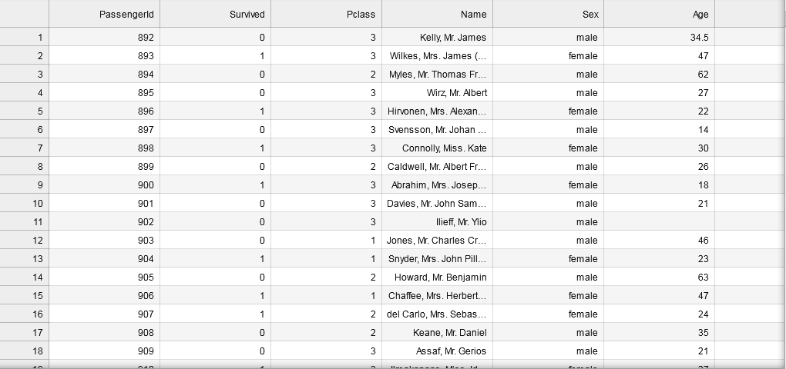

**Titanic DataSet**

**Programs :**

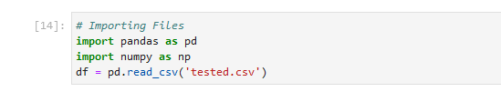

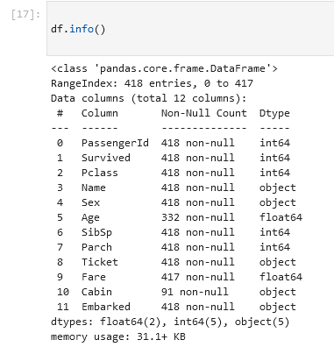

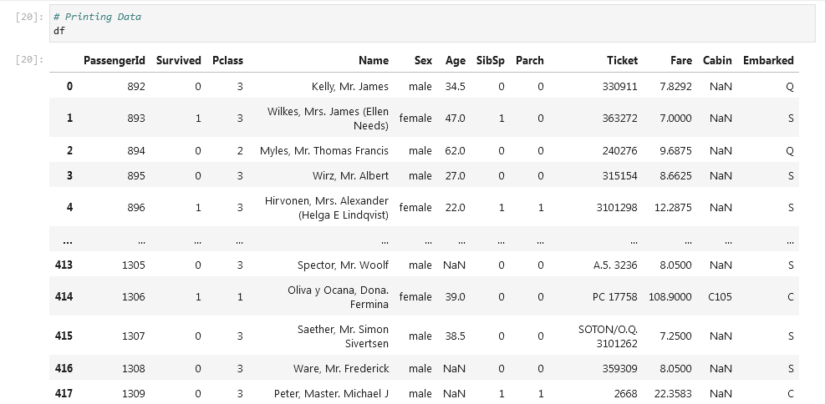

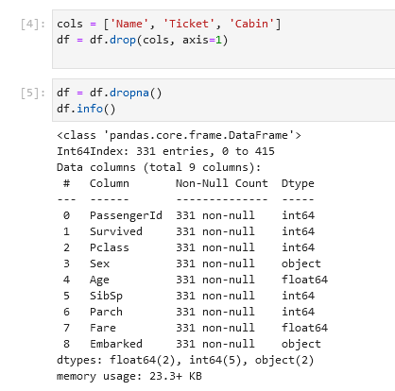 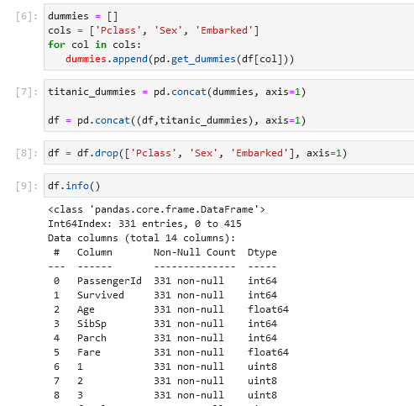

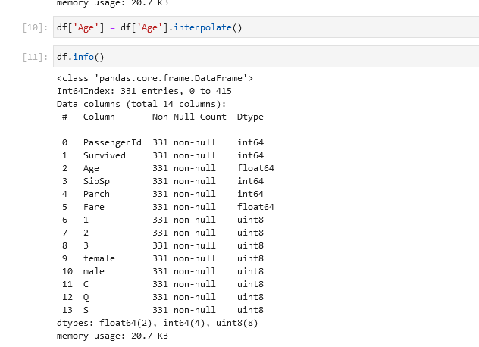

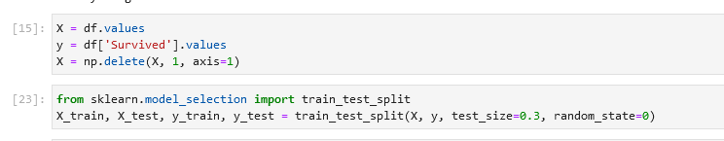

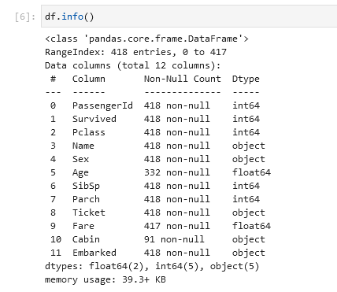

**EXPERIMENT NO. 3**

|  |
| --- |
| **Student Name and Roll Number: Avtar Singh / 20CSU241** |
| **Semester /Section: 5th / FSB** |
| **Link to Code:** |
| **Date:** |
| **Faculty Signature:** |
| **Grade:** |

|  |
| --- |
| **Objective(s):**   * To perform different encoding schemes. * To prepare dataset by converting categorical data to numeric form for machine learning. * To understand and implement label encoding and one hot encoding. |
| **Outcome:**  Students will be able to understand different encoding schemes to prepare data for machine learning. |
| **Problem Statement:**  To apply different feature encoding schemes on the given dataset. |
| **Background Study:**Machine learning models require all input and output variables to be numeric. This means that if your data contains categorical data, you must encode it to numbers **before you can fit and evaluate a model**. The two most popular techniques are Label Encoding and One-Hot Encoding. |
| **Question Bank:**  1. Can ML algorithms handle categorical data directly?  2. What are the different schemes for encoding categorical data?  3. Differentiate between Label Encoding and One Hot Encoding? |

**Student Work Area**

**Algorithm/Flowchart/Code/Sample Outputs**

|  |
| --- |
|  |
|  |
|  |
|  |

**EXPERIMENT NO. 4**

|  |
| --- |
| **Student Name and Roll Number: Avtar Singh / 20CSU241** |
| **Semester /Section: 5th / FSB** |
| **Link to Code:** |
| **Date: 15/09/2022** |
| **Faculty Signature:** |
| **Grade:** |

|  |  |  |  |  |  |
| --- | --- | --- | --- | --- | --- |
| |  | | --- | | **Objective(s):**   * To understand the importance of feature selection * To differentiate between different types of feature selection. * Build a model using feature selection techniques. | | **Outcome:**  Students will be familiarized with model building using feature selection techniques and  optimization. | | **Problem Statement:**  Write a program to apply filter feature selection techniques. | | **Background Study:**Feature selection is the process of reducing the number of input variables when developing apredictive model. It is desirable to reduce the number of input variables to both reduce thecomputational cost of modeling and, in some cases, to improve the performance of the model. | | **Question Bank:**  1. What are different filter feature selection techniques?  There are mainly 3 ways for feature selection: Filter Methods( that we are gonna see in this blog) Wrapper Method( Forward, Backward Elimination) Embedded Methods(Lasso-L1, Ridge-L2 Regression)  2. How feature selection techniques depend on the data type of input features and output variable?  3. What is the mathematics behind Pearson’s Correlation to rank features? | |
|  |
|  |

**Student Work Area**

**Algorithm/Flowchart/Code/Sample Outputs**

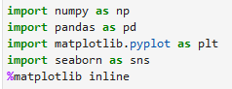



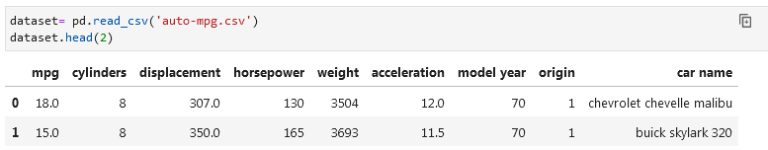

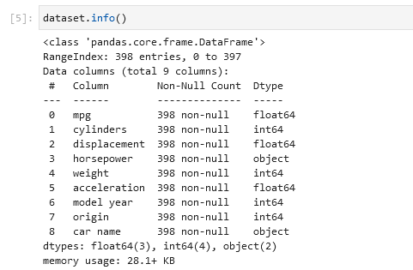

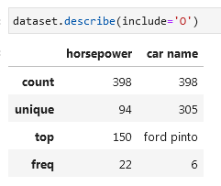

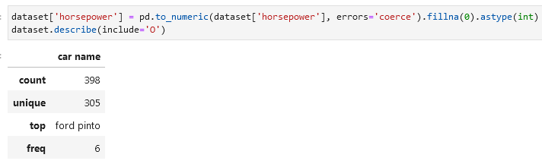

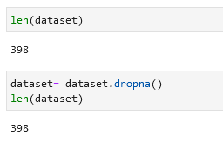 

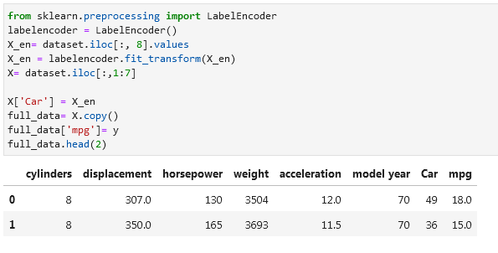

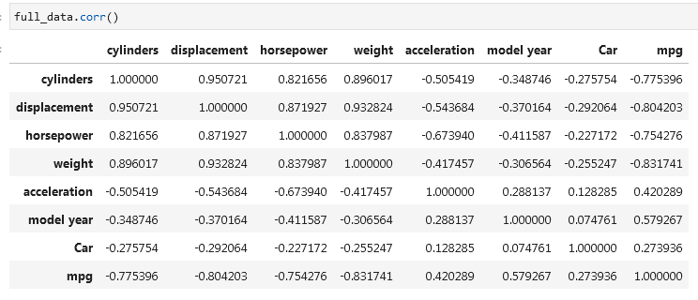

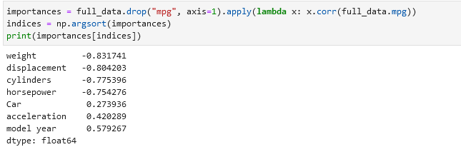

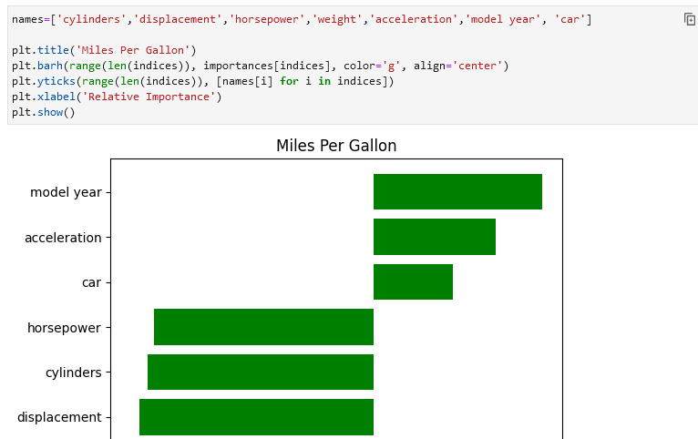

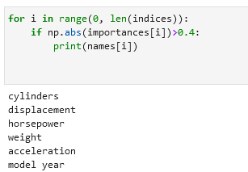

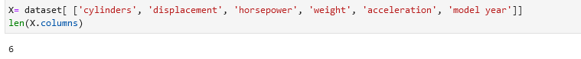

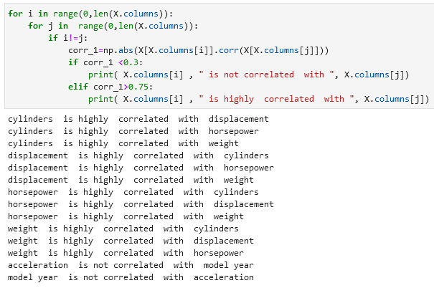

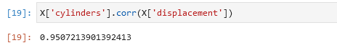

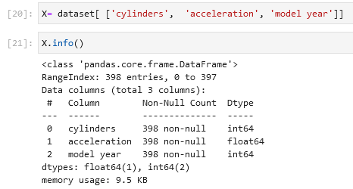

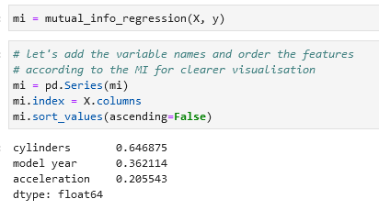

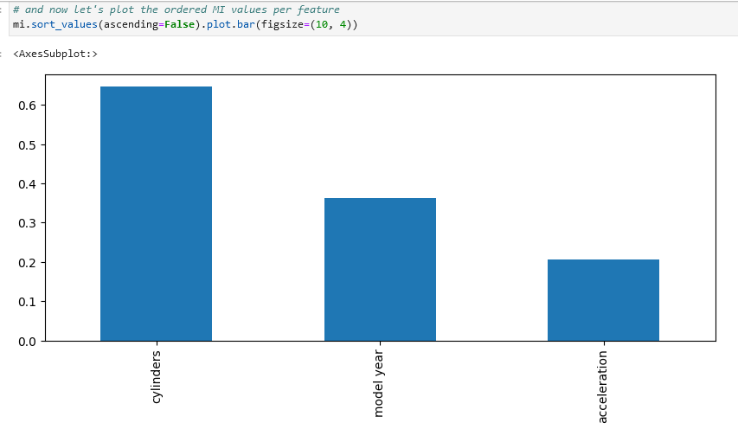

**EXPERIMENT NO. 5**

|  |
| --- |
| **Student Name and Roll Number: Avtar Singh / 20CSU241** |
| **Semester /Section: 5th / FSB** |
| **Link to Code:** |
| **Date:** |
| **Faculty Signature:** |
| **Grade:** |

|  |
| --- |
| **Objective(s):**   * Study Dimensionality Reduction. * Understand the basic principle behind Principal Component Analysis. |
| **Outcome:**  Students will be familiarized with Dimensionality Reduction especially Principal Component  Analysis (PCA). |
| **Problem Statement:**  Reduce dimensionality of Iris dataset using Principal Component Analysis. |
| **Background Study:**Principal component analysis is a statistical technique that is used to analyze the interrelationshipsamong a large number of variables and to explain these variables in terms of a smaller number ofvariables, called principal components, with a minimum loss of information. |
| **Question Bank:**  1. What is dimensionality reduction?  2. Differentiate between Feature Selection, Feature Engineering and Dimensionality Reduction.  3. What are principal components? |

**Student Work Area**

**Algorithm/Flowchart/Code/Sample Outputs**

**EXPERIMENT NO. 6**

|  |
| --- |
| **Student Name and Roll Number: Avtar Singh / 20CSU241** |
| **Semester /Section: 5th / FSB** |
| **Link to Code:** |
| **Date:** |
| **Faculty Signature:** |
| **Grade:** |

|  |
| --- |
| **Objective(s):**   * Understand Simple Linear Regression (SLR). * Study about the different performance metrics of SLR. |
| **Outcome:**  Student will be familiarized with regression problems and SLR as a solution to single feature problem. |
| **Problem Statement:**  To apply Simple Linear Regression on the given dataset. |
| **Background Study:**  Simple linear regression isan approach for predicting a response using a single feature. It is assumed that the two variables are linearly related. Hence, we try to find a linear function that predicts the response value(y) as accurately as possible as a function of the feature or independent variable(x). |
| **Question Bank:**  1. What is a regression problem?  2. How Simple Linear Regression (SLR) helps in solving regression problems containing an input feature and an output variable?  3. What are the different performance metrics that can be used for evaluating SLR? |

**Student Work Area**

**Algorithm/Flowchart/Code/Sample Outputs**

**EXPERIMENT NO. 7**

|  |
| --- |
| **Student Name and Roll Number: Avtar Singh / 20CSU241** |
| **Semester /Section: 5th / FSB** |
| **Link to Code:** |
| **Date:** |
| **Faculty Signature:** |
| **Grade:** |

|  |
| --- |
| **Objective(s):**   * Understand mathematics behind Multiple Linear Regression (MLR). * Solving linear regression problems containing more than one independent feature using MLR. |
| **Outcome:**  Students will be familiarized with Multiple Linear Regression for solving linear regression problems. |
| **Problem Statement:**  To apply multiple linear regression on any regression dataset. |
| **Background Study:**  Multiple Linear Regressionattempts to model the relationship between two or more features and a response by fitting a linear equation to observed data. |
| **Question Bank:**  1. What is MLR?  2. Differentiate between SLR and MLR? |

**Student Work Area**

**Algorithm/Flowchart/Code/Sample Outputs**

**EXPERIMENT NO. 8**

|  |
| --- |
| **Student Name and Roll Number: Avtar Singh / 20CSU241** |
| **Semester /Section: 5th / FSB** |
| **Link to Code:** |
| **Date:** |
| **Faculty Signature:** |
| **Grade:** |

|  |
| --- |
| **Objective(s):**   * Study and understand about Polynomial Regression on non-linear regression data. * Study the mathematics behind Polynomial Regression. |
| **Outcome:**  Students will be familiarized with handling of regression data having non-linear relationship between input and output. |
| **Problem Statement:**  To apply Polynomial Linear Regression on the given dataset. |
| **Background Study:**  **Polynomial Regression**is a form of linear regression in which the relationship between the independent variable x and dependent variable y is modeled as an nth degree polynomial. Polynomial regression fits a nonlinear relationship between the value of x and the corresponding conditional mean of y, denoted E(y |x). |
| **Question Bank:**  1. What is non-linear relationship between input and output?  2. How Polynomial Regression is used to handle non-linear relationship? |

**Student Work Area**

**Algorithm/Flowchart/Code/Sample Outputs**

**EXPERIMENT NO. 9**

|  |
| --- |
| **Student Name and Roll Number: Avtar Singh / 20CSU241** |
| **Semester /Section: 5th / FSB** |
| **Link to Code:** |
| **Date:** |
| **Faculty Signature:** |
| **Grade:** |

|  |
| --- |
| **Objective(s):**   * Study Logistic Regression. * How Logistic Regression is used to solve classification problems. |
| **Outcome:**  Students will be familiarized with Logistic Regression and performance metrics to calculate its performance on the given dataset. |
| **Problem Statement:**  To solve classification problems using Logistic Regression. |
| **Background Study:**  Logistic regression is a classification technique which helps to predict the probability of an outcome that can only have two values. Logistic Regression is used when the dependent variable (target) is categorical. A logistic regression produces a logistic curve, which is limited to values between 0 and 1. |
| **Question Bank:**  1. What is Logistic Regression?  2. How Logistic Regression is used for solving classification problems?  3. Why sigmoid function is used in it? |

**Student Work Area**

**Algorithm/Flowchart/Code/Sample Outputs**

**EXPERIMENT NO. 10**

|  |
| --- |
| **Student Name and Roll Number: Avtar Singh / 20CSU241** |
| **Semester /Section: 5th / FSB** |
| **Link to Code:** |
| **Date:** |
| **Faculty Signature:** |
| **Grade:** |

|  |
| --- |
| **Objective(s):**   * Study K-Nearest Neighbour algorithm (KNN). * Understand the working principle behind KNN. |
| **Outcome:**  Students will be familiarized with classification technique using KNN. |
| **Problem Statement:**  To solve classification problems using KNN classification. |
| Background Study:  K-nearest neighbors (KNN) algorithm is a type of supervised ML algorithm which can be used for both classification as well as regression predictive problems. However, it is mainly used for classification predictive problems in industry. The following two properties would define KNN well −   * Lazy learning algorithm − KNN is a lazy learning algorithm because it does not have a specialized training phase and uses all the data for training while classification. * Non-parametric learning algorithm − KNN is also a non-parametric learning algorithm because it doesn’t assume anything about the underlying data.   K-nearest neighbors (KNN) algorithm uses ‘feature similarity’ to predict the values of new datapoints which further means that the new data point will be assigned a value based on how closely it matches the points in the training set. The most common parameter used to perform matching is Euclidean distance between the points. |
| **Question Bank:**  1. What is KNN classifier?  2. How KNN makes use of Euclidean distance to calculate nearest neighbor?  3. What are the other distances that can be used for nearest neighbor?  4. What are the various performance metrics used for classification problems? |

**Student Work Area**

**Algorithm/Flowchart/Code/Sample Outputs**

**EXPERIMENT NO. 11**

|  |
| --- |
| **Student Name and Roll Number: Avtar Singh / 20CSU241** |
| **Semester /Section: 5th / FSB** |
| **Link to Code:** |
| **Date:** |
| **Faculty Signature:** |
| **Grade:** |

|  |
| --- |
| **Objective(s):**   * Understand and study Naïve Bayes (NB) Classifier. * Understand Naïve Bayes theorem behind it. |
| **Outcome:**  Students will be familiarized with NB classification technique. |
| **Problem Statement:**  To solve classification problems using Naïve Bayes. |
| **Background Study:**  Naïve Bayes Classifier is a probabilistic classifier and is based on Bayes Theorem.  In Machine learning, a classification problem represents the selection of the Best Hypothesis given the data.  Given a new data point, we try to classify which class label this new data instance belongs to. The prior knowledge about the past data helps us in classifying the new data point.The Naïve Bayes theorem:    gives us the probability of Event A to happen given that event B has occurred. |
| **Question Bank:**  1. What is Bayes theorem?  2. How Naïve Bayes classifier helps for solving classification problems?  3. What is the condition on features that should be fulfilled for successful application of Naïve Bayes method? |

**Student Work Area**

**Algorithm/Flowchart/Code/Sample Outputs**

**EXPERIMENT NO. 12**

|  |
| --- |
| **Student Name and Roll Number: Avtar Singh / 20CSU241** |
| **Semester /Section: 5th / FSB** |
| **Link to Code:** |
| **Date:** |
| **Faculty Signature:** |
| **Grade:** |

|  |
| --- |
| **Objective(s):**   * Understand and study Support Vector Machines (SVM). * To study how linear hyperplane is calculated to differentiate between two classes. * Basic understanding of the different variants of SVM. |
| **Outcome:**  Students will be familiarized with Support Vector Machines classifier. |
| **Problem Statement:**  To solve classification problems using SVM. |
| **Background Study:**  In machine learning, support-vector machines (SVMs, also support-vector networks) are supervised learning models with associated learning algorithms that analyze data for classification and regression analysis.  Developed at AT&T Bell Laboratories by Vladimir Vapnik with colleagues,SVMs are one of the most robust prediction methods, being based on statistical learning frameworks or VC theory proposed by Vapnik (1982, 1995) and Chervonenkis (1974).  Given a set of training examples, each marked as belonging to one of two categories, an SVM training algorithm builds a model that assigns new examples to one category or the other, making it a non-probabilistic binary linear classifier. SVM maps training examples to points in space so as to maximise the width of the gap between the two categories. New examples are then mapped into that same space and predicted to belong to a category based on which side of the gap they fall. |
| **Question Bank:**  1. What is SVM?  2. What are the advantages of using SVM over other classifiers?  3. What do you mean by support vectors? |

**Student Work Area**

**Algorithm/Flowchart/Code/Sample Outputs**

**EXPERIMENT NO. 13**

|  |
| --- |
| **Student Name and Roll Number: Avtar Singh / 20CSU241** |
| **Semester /Section: 5th / FSB** |
| **Link to Code:** |
| **Date:** |
| **Faculty Signature:** |
| **Grade:** |

|  |
| --- |
| **Objective(s):**   * Understand and study Decision Trees for classification problems. * Study about the information gain used to create decision trees. |
| **Outcome:**  Students will be familiarized with creation of decision trees. |
| **Problem Statement:**  Apply Decision Tree classifier for solving classification problems. |
| Decision tree analysis is a predictive modelling tool that can be applied across many areas. Decision trees can be constructed by an algorithmic approach that can split the dataset in different ways based on different conditions. Decision trees are the most powerful algorithms that falls under the category of supervised algorithms.  They can be used for both classification and regression tasks. The two main entities of a tree are decision nodes, where the data is split and leaves, where we got outcome. |
| **Question Bank:**  1. What is a decision tree?  2. How decision tree is created to solve problems?  3. List out the advantages and disadvantages of Decision Tree Classifiers? |

**Student Work Area**

**Algorithm/Flowchart/Code/Sample Outputs**

**EXPERIMENT NO. 14**

|  |
| --- |
| **Student Name and Roll Number: Avtar Singh / 20CSU241** |
| **Semester /Section: 5th / FSB** |
| **Link to Code:** |
| **Date:** |
| **Faculty Signature:** |
| **Grade:** |

|  |
| --- |
| **Objective(s):** |
| **Outcome:** |
| **Problem Statement:** |
| **Background Study:** |
| **Question Bank:** |

**Student Work Area**

**Algorithm/Flowchart/Code/Sample Outputs**

**EXPERIMENT NO. 15**

|  |
| --- |
| **Student Name and Roll Number: Avtar Singh / 20CSU241** |
| **Semester /Section: 5th / FSB** |
| **Link to Code:** |
| **Date:** |
| **Faculty Signature:** |
| **Grade:** |

|  |
| --- |
| **Objective(s):** |
| **Outcome:** |
| **Problem Statement:** |
| **Background Study:** |
| **Question Bank:** |

**Student Work Area**

**Algorithm/Flowchart/Code/Sample Outputs**

**Annexure 2**

**Introduction to AI and ML**

**CSL236**

Project Report



Faculty name: Student name:

Roll No.:

Semester:

Group:

**Department of Computer Science and Engineering**

**The NorthCap University, Gurugram- 122001, India**

**Session 2021-22**

**Table of Contents**

|  |  |  |
| --- | --- | --- |
| **S.No** |  | **Page No.** |
| **1.** | **Project Description** |  |
| **2.** | **Problem Statement** |  |
| **3.** | **Analysis**  **3.1 Hardware Requirements**  **3.2 Software Requirements** |  |
| **4.** | **Design**  **4.1 Data/Input Output Description:**  **4.2 Algorithmic Approach / Algorithm / DFD / ER diagram/Program Steps** |  |
| **5.** | **Implementation and Testing (stage/module wise)** |  |
| **6.** | **Output (Screenshots)** |  |
| **7.** | **Conclusion and Future Scope** |  |